A470-AM,N-NW**-**Kwakwaka'wakw-Totem Pole- late 20th century

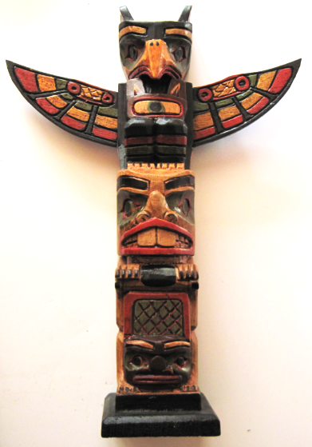 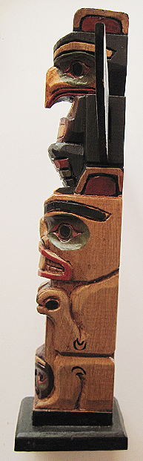 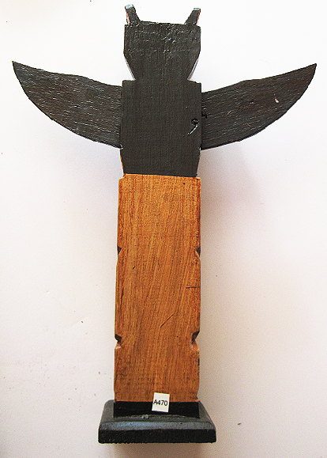 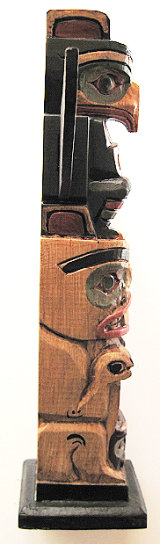

Figs. 1-4. Kwakwaka'wakw-Totem Pole of mink, beaver and thunderbird.

**Case no.: 8**

**Accession Number: A470**

**Formal Label:** AM,N-**NW-**Kwakwaka'wakw-Totem Pole-Late 20th century

**Display Description:**

ThisKwakwaka'wakw-Totem Pole of mink, beaver and thunderbird incorporates the following myth:

Shaman, the shape-shifting trickster, took Beaver’s shape so he could swim cold waters in search of Thunderbird, who lived high above the water-drenched rain forest. Shaman once captured Sun from the skies, but Raven had freed Sun. Now Shaman’s quest was to capture Thunderbird’s power.   
When Shaman put on Beaver's fur he put on Beaver’s shape. Then he approached Thunderbird with the message that the village below was confronted by unrelenting flood waters, "Maybe you could empower me with your lightning so I could start fires so fierce that the flood waters would retreat to the ocean."   
Thunderbird just glowered at this request since he knew he would just be giving away some of his power. He thought: “Would Beaver, my friend, really want this?”  
Then Shaman-in-shape-of-Beaver noticed that Thunderbird said nothing so he asked again, "Give me the strength of your wings so that thunder claps will smash the flood away."   
Thunderbird listened to these words but they resonated with something deep inside “Do not trust these words.” “Why?” he asked himself. It was the manner of asking. Of the context of asking. It was not Beaver asking. Thunderbird now could not help that his wings began to flutter with his power. They fluttered as he looked deeply into the dark eyes of Shaman-in-shape-of-Beaver. Then, without warning Thunderbird’s wings clashed together in a clap. With incredible force he sent Shaman-in-shape-of-Beaver spinning down the mountainside into the mud flats below.   
Thunderbird looked down on the village in the afternoon Sun only to see Beaver back in his den. Mink in his burrow. All was right with the world. His job was done without really doing anything except protecting his powers from being misused.

**LC Classification:** E99.K9

**Date or Time Horizon:** Late 20th century

**Geographical Area:** Pacific NW Coast

**Map, GPS coordinates:** [50°41′40″N 127°24′43″W](https://tools.wmflabs.org/geohack/geohack.php?pagename=Fort_Rupert&params=50_41_40_N_127_24_43_W_region:CA-BC_type:city), Fort Rupert, the traditional home of theKwakwaka'wakw

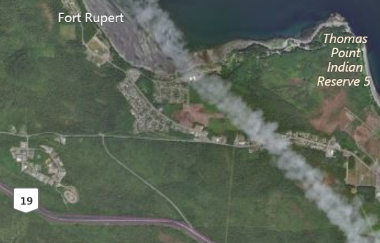

Fig. 5. Map of Fort Rupert and the Kwakwaka'wakw Reserve. After www.bing.com

**Cultural Affiliation:** Kwakwaka'wakw

**Media:** maple wood; green, red, black, orange paint.

**Dimensions:** H 289.32 mm, 11.39 in; W224.92, 8.88 in

**Weight:** 278 gm, 9.75 oz

**Condition: original**

**Provenance:** artist

**Discussion:**

In these days of fake news on Facebook and Twitter it is becoming all the more important for young and old alike to resist being taken in by those who take the shape of friends over the internet but without really never having met them in the flesh. Resist giving away your powers, your credit card numbers, your private information. Protect your identity from being misused.

Identify fake news from people you don’t know by researching and understanding the issues yourself. Tell your friends to resist these temptations as well. Like Thunderbird, look deeply into the eyes of shape-shifters, confront fake news charlatans and conspiracy hoaxers. Now you are in control of your own identity, your own powers and your own democratic actions.

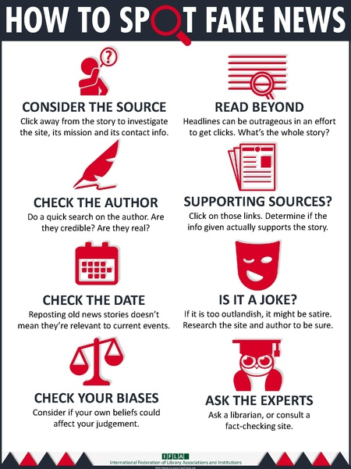

Fig. 6. IFLA infographic based on FactCheck.org’s 2016 article ["How to Spot Fake News"](http://www.factcheck.org/2016/11/how-to-spot-fake-news/) in PDF format. From <https://www.ifla.org/files/assets/hq/topics/info-society/images/how_to_spot_fake_news.pdf>

**References:**

Goodfellow, Anne Marie. 2014. *Talking in Context: Language and identity in Kwakwaka'wakw Society*. Montreal: McGill-Queen's University Press.

Hunt, George. 1925. *Contributions to the Ethnology of the Kuakiutl*. [Edited] by Franz Boas. New York; Vienna printed.

Modzelewski, Michael. 1992. [*Inside passage: living with killer whales, bald eagles, and Kwakiutl Indians*](http://www.worldcat.org/title/inside-passage-living-with-killer-whales-bald-eagles-and-kwakiutl-indians/oclc/35686590&referer=brief_results). New York, NY: HarperPerennial.

[Rohner, Ronald P.](http://webcat1.library.ubc.ca/vwebv/search?searchArg=Rohner%2C%20Ronald%20P.&searchCode=NAME&searchType=4) and [Evelyn C.](http://webcat1.library.ubc.ca/vwebv/search?searchArg=Rohner%2C%20Evelyn%20C.&searchCode=NAME&searchType=4) Rohner. 1970. *The Kwakiutl Indians of British Columbia.* New York: Holt, Rinehart and Winston.